

HOSPITAL WIDE

POLICY & PROCEDURES



COMMUNITY HEALTH CENTER UDAYPUR, KEONJHAR, ODISHA

CONTENT

- Condemnation Policy.
- Visitor’s Policy.
- Privacy, Dignity and confidentiality policy of patient.
- Maintaining of Patient Records its security and sharing of information.
- Consent policy.
- Consultation and bed allocation policy.
- Availability of EDL and stock out management policy
- Intra departmental and higher centre referral policy.
- Grievance Redressal policy.
- No smoking policy.
- Quality Policy

CONDEMNATION POLICY GOVT.

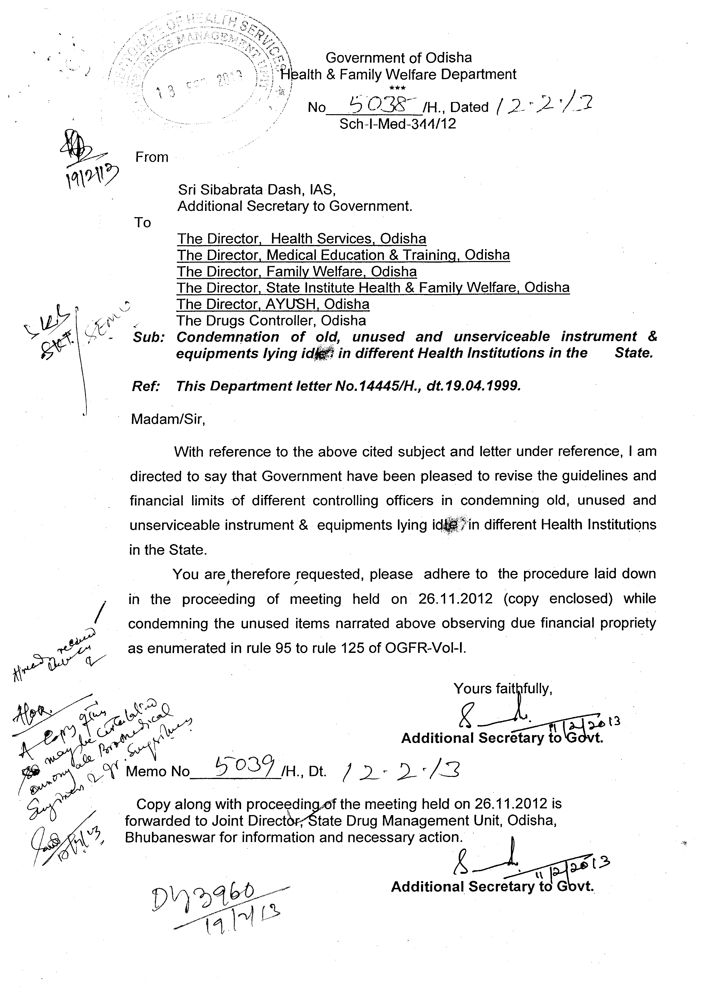

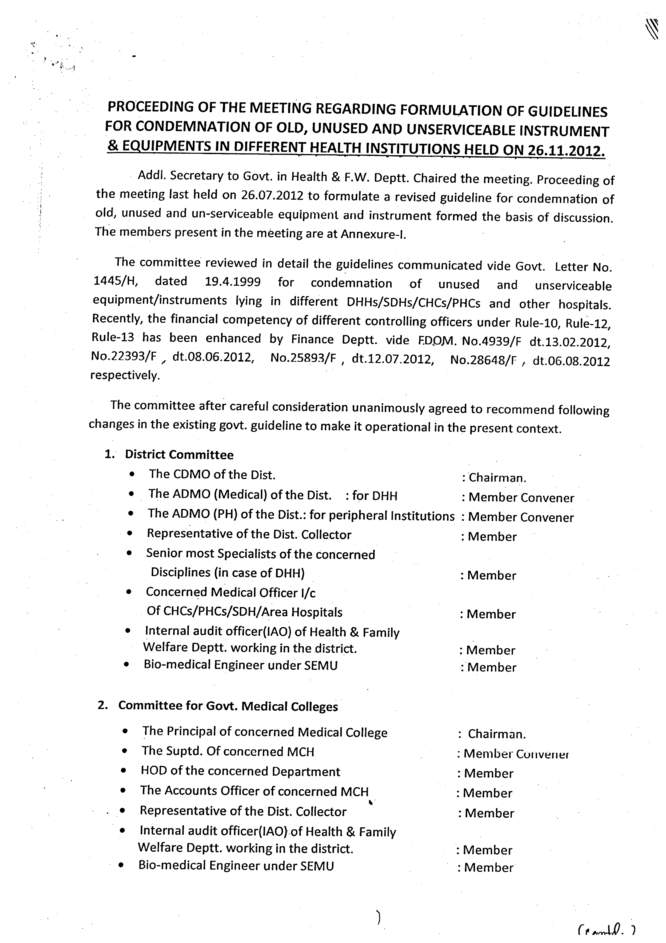

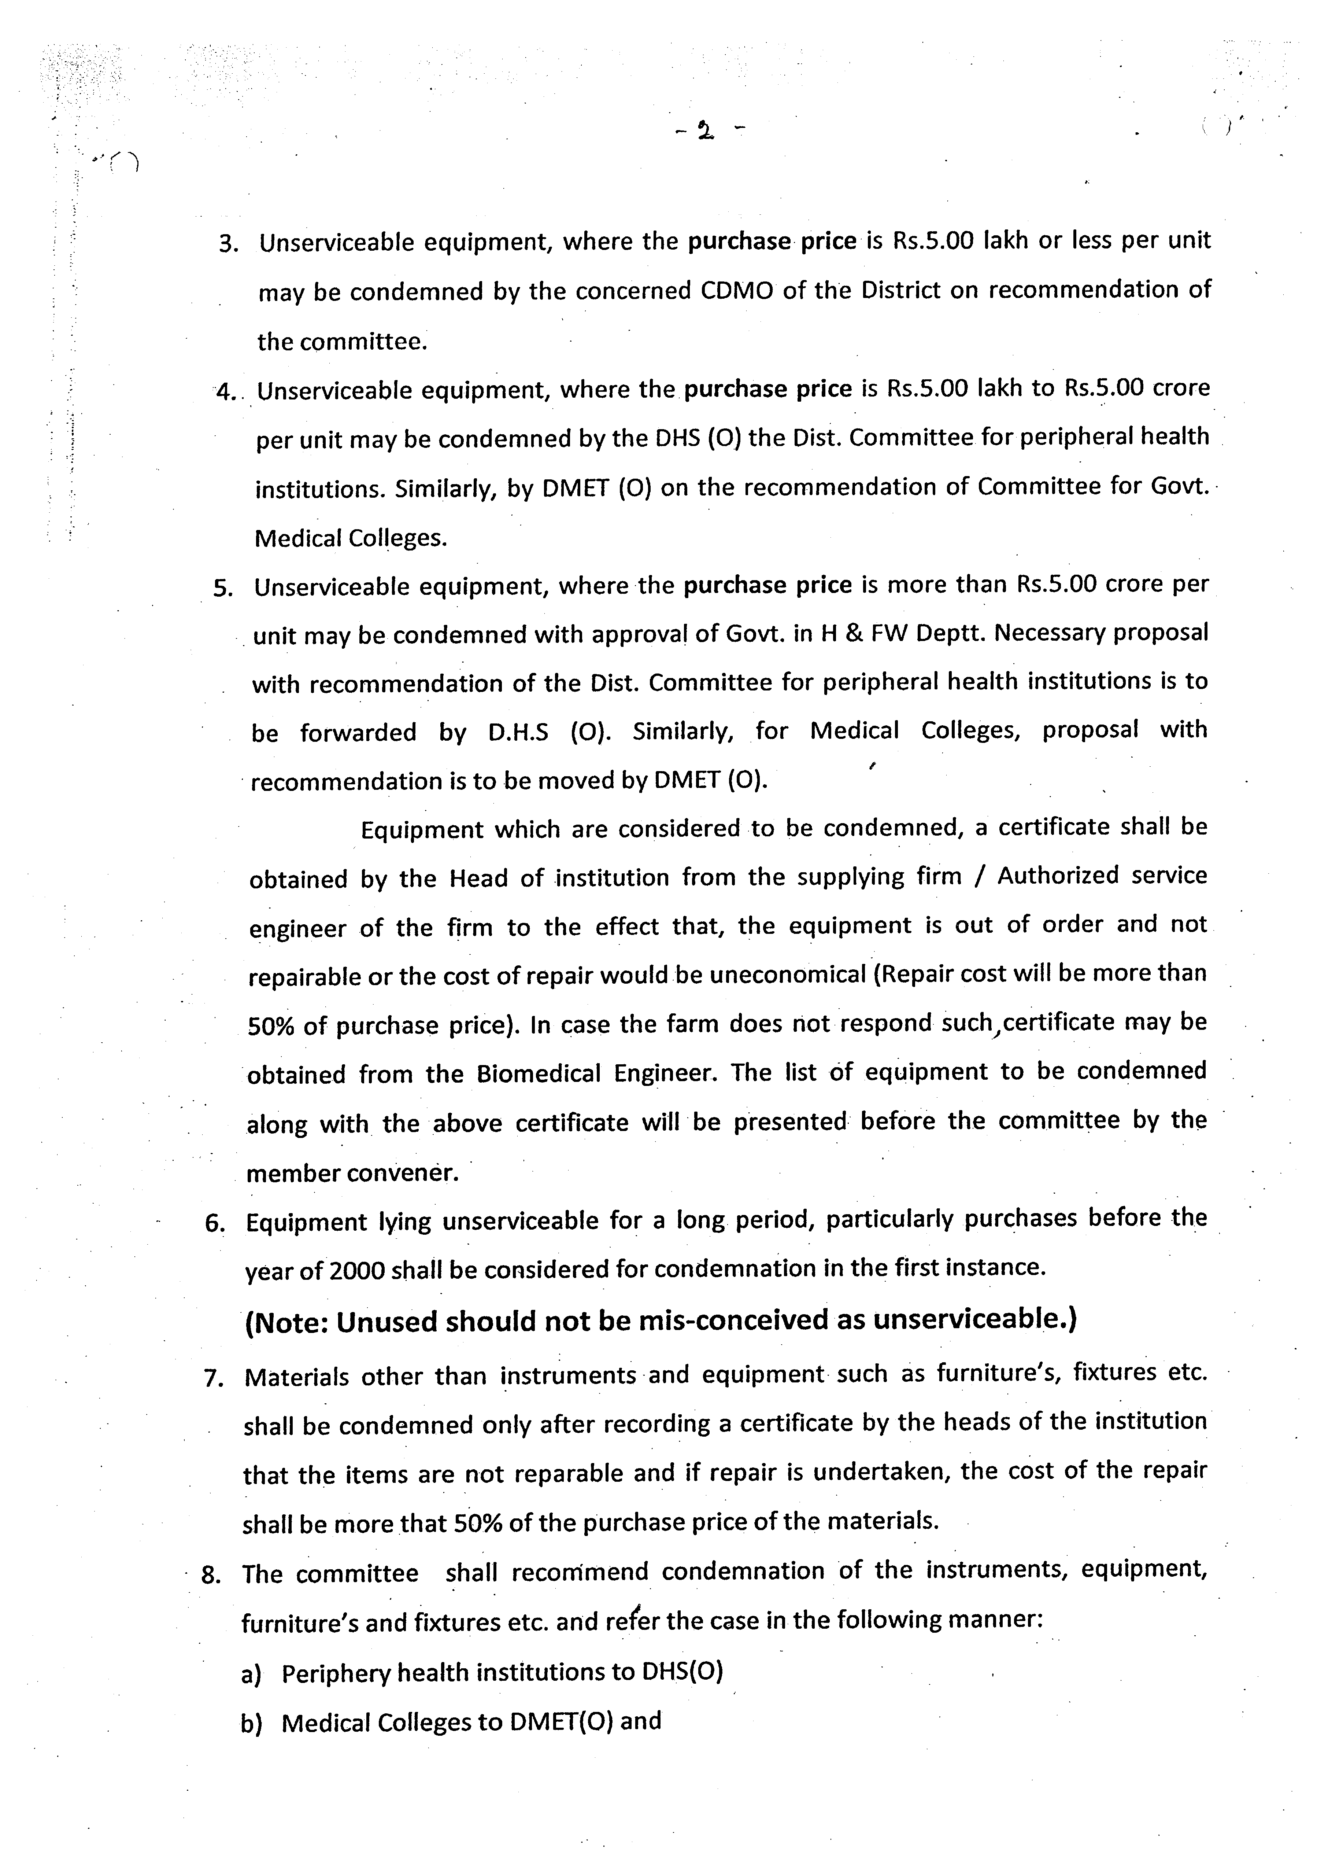

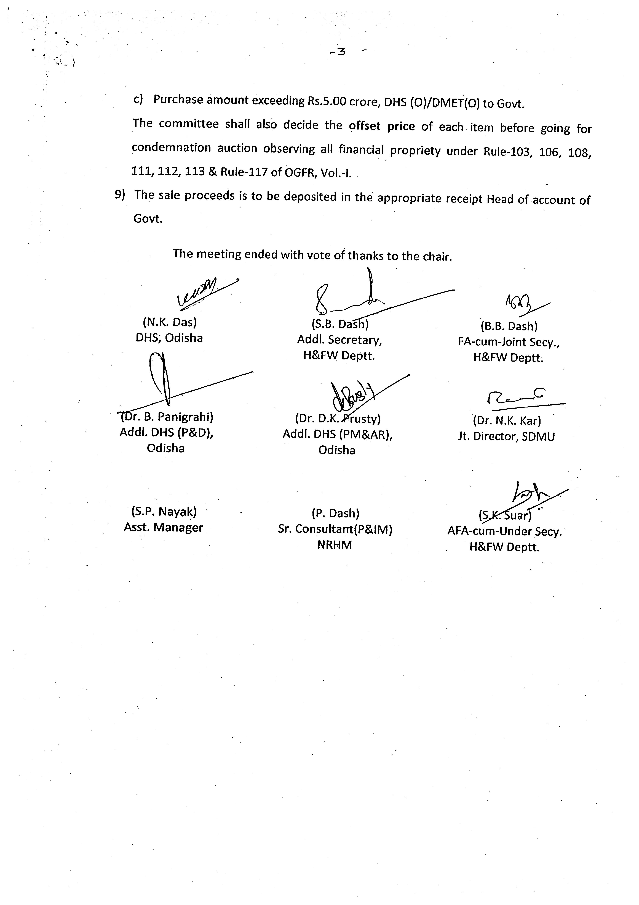

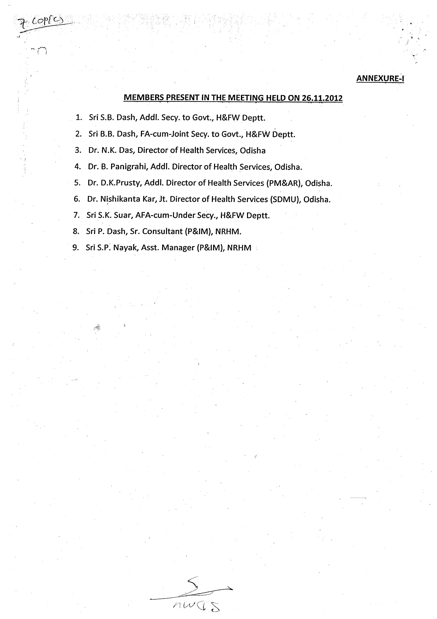

Visitors Policy-
Objective- To make sure that our patients gets the rest they need and other patients are not disturbed .
2. To help and protect our patients, visitors and employees from exposures to respiratory , viral illness including seasonal influenza.

Policy
- Visitors must be age of 12 years.
- Siblings will be allowed to visit the maternity units as long as they do not exhibit symptoms of cold or other respiratory infection .
- Request to visit in compassionate care, situation may be approved by the nursing sister. While we are fully appreciate the impact of this policy on our patients and visitors, we believe these action are necessary to help, prevent the spread of illness with in the hospital

Visiting Hours

Daily visiting hours an rules are established for the comfort and safety of your loved one as well as for other patients in the hospital, we welcomes visitors and realize that you are integral to our patients recovery.
.

General Visiting Hours
  - Before and after the round of doctor.
  - Please limit your stay to 15-20 minutes
  - Maximum no. of visitors in the rooms are 02 at a time
  - Children under the age of 12 are not permitted in wards nor may they Wait in the waiting area
  - A care giver may interrupt your visit during patients care routine.
  - If you are unfit please postpone your visit.

Maternity Visiting Hours.
- Father May Visit 24 hours with an identification band or pass provided by the PHC staff
- Siblings of all age may visit
- all visitors including children must be healthy with no rashes , infection , cold , run-noses, diarrhea , recent exposure to infectious diseases .

PATIENT CONFIDENTIALITY PRIVACY & DIGNITY

Purpose: The policy outlines the requirements relating to the way information is collected, accessed, used, stored or disclosed.

Responsibility: All staff members of the CHC, UDAYPUR in every department.

Standards:
Patients, CHC, UDAYPUR staff and Hospital Management Committee have the right to complete confidentiality. Medical / departmental records and information regarding patients/ company matters are legally protected for protection of privacy.
  - In the course of performing work responsibilities, information is considered confidential with regard to patients, their families, their physicians, CHC, UDAYPUR staff details, and/or CHC, UDAYPUR matters. As a condition of employment, personnel are cautioned not to discuss any such information with others.
  - CHC, UDAYPUR staff will extend their ethical responsibility of patient confidentiality, to hospital /organizational confidentiality by not disclosing any hospital related matters where patients can hear, other than as a professional response to general inquiries. CHC, UDAYPUR personnel should avoid making any public statements related to hospital /organizational confidential matters, leaving the responsibility for such statements to the manager who will coordinate with the public relations department.

CHC, UDAYPUR staff shall NOT release any general information such as verification that a patient has visited the hospital, the general nature of the injuries, and the degree of seriousness of His/her condition, such as "critical" "satisfactory" or "not serious’; NOR disclose detailed information to the press without the signed authorization of the patient or Register next of kin. Any such enquiries shall be directed to Administrator.
  - CHC, UDAYPUR staff will prevent the disclosure of any personal or medical information obtained during the course of their professional duties, with anyone except other health professionals directly involved in the care. The patient right to privacy extends beyond their discharge from hospital, and beyond their death.
  - Personnel shall not discuss patients in common areas or outside of the facility.
  - Medical records are accessed only by staffs who are involved with the patient's care.

Medical records are protected from unauthorized access by storing in protected areas when outside of the Medical Records Department.
  - The computer system requires access codes to obtain information from sensitive areas, i.e., business office, medical records, and laboratory results.
  - Patient physical assessments are conducted in a location that affords visual and auditory privacy.

MAINTENANCE OF PATIENT RECORD:-

Medical records are maintained in a manner that is current, detailed, organized, and easily accessible to authorized person. All patient data is filed in the medical record, (i.e., lab, x- ray, consultation notes, etc.). Radiology investigations are also attached and are part of the medical records.

General:
    - At the time of registration a unique identifier of patient is given on every file
    - All orders are written in indelible ink for handwritten documentation. No pencil entries are made
    - All notes and orders are dated, named dated, timed and signed (include day, month, and year).
    - Timing of entries is mentioned, especially on Medication orders and administration, Pre- Operative, and Nursing documentation.
    - For records on electronic media it is preferable that the date and time is automatically generated.
    - All notes are legible and include clear, concise patient information.
Orders are authenticated and signatures mentioning professional title of the author are there. Orders are written in the designated place marked for the purpose in the medical
Record/ case sheet/ OPD Card taking care, not disturbing the Chronological order.

Making Entries in the Medical Record:

- All disciplines document according to discipline specific documentation standards.
- Entries written in error have a single line drawn through and "ERROR" written above. Never erase, obliterate or use liquid paper correction fluid on a patient's record.
- All forms in the record must have been previously approved.
- No part of the medical record is ever to be removed after entry.
- The patient's name and medical record number must appear on every record page/document in case of electronic medical record.
- Rubber stamps are not allowed for physician signatures.
- Inpatient Care is documented in the Medical Record and includes:
  - Reason for admission, diagnosis, and plan of care is included in the documents.
  - Evidence of the initial patient assessment and all subsequent reassessments.
  - Documentation of interventions based on physician orders and/or on unit standards of care or approved protocols.
  - Documentation of nursing care provided.
  - Any Procedure performed in detail, Name, signature, and date, time on every entry made in the record.
  - The record is legible.
  - The records are in a chronological order demonstrating the continuity of care.

  - Transfer notes is in accordance to the policy of transfer and should includes- Date, reason for discharge and name of the receiving hospital.
  - Medication administration is recorded on the Medical Administration Record or area specific forms
  - Specific care provided is evidenced on the patient care flow sheet.
  - Patient discharge instructions

Content of Medical Records (Minimum Requirements) List:

    - Patient Identification Details on each page (e.g.: Name, Age, Sex, Ward/Bed)
    - Date and Time of examination
    - Presenting Complaints
    - Complete History
    - Assessment Findings
    - Provisional / Admitting Diagnosis
    - Reason For Admission in case of IPD Case files
    - Investigation chart and Reports
    - Treatment Plan
    - Medication Orders
    - Progress notes and orders
    - Critical Care Notes as applicable
14. Handover Notes.
- Referral Notes where ever applicable
- Fitness for Discharge
- Condition on discharge.
- Discharge summary with all instructions:

  - Final diagnosis
  - Reason for admission, including a brief clinical statement of the chief complaint and history of the present illness
  - physical, laboratory, x-ray and other diagnostic procedures and studies
  - Medical and/or surgical treatment, including the patient's response, and complications
  - Condition on discharge, including, for example ability to ambulate, degree of self-care, and ability to work
- Instructions for continuing care, including information on diet, medications, activities, and follow-up.
  - Prescribed medications (to clearly mention drug, dose, route and duration)
  - Follow up date, time and place
  - Emergency Contact information after discharge
In all IPD cases duplicated copies of discharge summary are prepared. While one copy is issued to the patient at discharge, the other one is filed in the patient’s case file and is retained by the medical records dept. (Please refer to the document-“Discharge of patients”). Discharge summary is prepared and signed or countersigned by the clinician in- charge.Recording times and signatures
  - Notes should be written during the patient encounter or immediately afterwards. Notes should be in a straightforward, purposeful and factual style. If on paper, write such that it cannot be erased. Use clear handwriting that is large enough to be readable on photocopying and ensure that you can be identified as the author.
  - All notes MUST have a date, time, signature and name/stamp of Physician. Note that the stamp shall not replace the manual signatures.

GENERAL CONSENT

Purpose: The purpose of obtaining a patient's general consent is to ensure that patient is informed about the routine medical and nursing care that will be provided to the patient based on which he takes decision of getting registered and admitted in this hospital.
General consent is not an alternative to Informed Consent. Informed consent shall be taken in all situations

Scope: Scope of general consent includes consent for clinical consultation, admission, disclosure of information required for clinical management (under confidence), routine medical examination (physical examination, palpation, percussion, auscultation), routine lab and imaging investigations, general nursing care, diet and physiotherapy assessment and counselling

POLICY:
  - General consent shall be taken from all patients being registered and admitted in the hospital & at the time when patient enters the hospital. General consent must be obtained from an adult patient with decision-making capacity, or person legally authorized to consent on behalf of the patient.
  - In case of the patients from whom consent can not be taken, (for e.g. in case of unattended, unconscious patient, Minor patients) consent shall be taken from next kin/legal guardian/relative.
  - If consent is not obtained (for e.g. in case of unattended, unconscious patient, Minor patients), the reason must be documented in the patient medical record.
  - General consent shall be taken in written with patients / relative’s signature at the time of admission and as implied consent at the time of registration.

INFORMED CONSENT

Purpose: To define the obligations in obtaining and documenting informed consent by CHC UDAYPUR Consultants and staff.

Policy: CHC UDAYPUR Consent Policy will include all guidelines laid down by the Medical Council of India’s Code of Medical Ethics. Doctors should familiarize themselves with guidance relevant to their area of practice.

THE PATIENT’S RIGHTS
  - Patients must be given information, in a way that they can understand, to enable them to exercise their right to make informed decisions about their care.
  - A patient has the right to give or withhold consent prior to examination or treatment.
  - Patients must be allowed to decide whether they will agree to the treatment and they may refuse treatment or withdraw consent at any time.
  - Minors and incompetent adult’s rights regarding informed consent will be exercised through their parents or legal representative.
  - The physician performing a medical or surgical procedure on a patient is responsible for obtaining the patient's informed consent prior to the treatment or procedure.

Special Instructions:
- Elements of Informed Consent
Informed consent is a process in which the physician provides adequate information for the patient or patient's legal representative to make an informed decision on the proposed treatment, including medications or procedure.

- Specifically, the physician must disclose in a reasonable manner all significant medical information that the physician believes is relevant and material to making an informed decision by the patient in deciding whether or not to undergo the procedure or treatment. This information should include all of the following:
  - The nature of the patient's condition;
  - The proposed treatment, possible treatment alternatives, including no treatment;
  - The benefits of the proposed procedure, as well as frequently occurring and significant risks of the proposed treatment and alternatives;
  - The consequences of no treatment;

  - If applicable, the possible use in education and/or research of blood or tissue removed from the patient not needed for further medical care.
  - The patient or patient's authorized representative should be given the opportunity to ask question and receive additional as required.
  - The patient should also be advised that it is not possible to predict or guarantee results.

Documentation
- If preoperative medication (sedation or pain medication) is to be administered, informed consent or verification of informed consent must be obtained prior to the administration of such medication.

- The physician must document in the medical record, on an approved hospital form when available, consent for all therapeutic and diagnostic procedures where disclosure of significant medical information, including significant and frequently occurring risks involved, would assist a patient in making an informed decision whether to undergo the proposed treatment or procedure. Such procedures include surgical and other invasive procedures, other treatments with significant risks, and transfusion of blood and/or blood products.
- The approved hospital forms must always be completed on all cases involving a procedure for which documented consent is required.

- Exceptions: Certain recognized exceptions to informed consent include:
- Medical Emergency: A procedure which may otherwise require informed consent may be performed without obtaining prior informed consent in an emergency when the patient is incapacitated and cannot make an informed decision, and the patient has a life or health- threatening situation requiring immediate treatment such that any delay in treatment would likely result in death, deterioration, or serious permanent impairment.

- Patient's Lack of Capacity to Consent: Patient is incapable or lacks the capacity to give consent. In these cases, suitable alternative procedures, including use of legal guardian where appropriate, should be initiated if no emergency exists.

- Minor: If the patient is under eighteen years of age, consent should be obtained and documented in the otherwise usual manner from the minor's parent or the minor's legal guardian. The specific facts and reasons the exception applies must be thoroughly documented in the medical record. These exceptions should not be made in lieu of appropriate consent process except under extraordinary circumstances.

Duration of Informed Consent
- Informed consent may be considered to have continuing force and effect until the patient revokes the consent, or until circumstances change so as to materially affect the nature of, or the risks or benefits of, the procedure and/or the alternatives to the procedure to which the patient consented. For example, if a patient has been admitted for a specific treatment or procedure, the consent should be valid through the course of the admission unless the patient's condition or treatment changes significantly. In that event, the physician should obtain a new informed consent. Generally, informed consent should be obtained and documented no longer than 60 days prior to a procedure, surgery, or treatment. After this time period, the informed consent should be re-obtained and re-documented by the physician.
- Revocation - A patient may revoke consent verbally or in writing. This should be communicated to the patient's physician and documented in the medical record.

Informed Consent for Continuing Therapy
Informed consent shall generally be obtained before each new procedure. However, patients in certain therapeutic programs involving a course of multiple treatments may consent to an entire course of routine therapy prior to the first treatment, and a single consent form may be signed for the entire course of treatment (not to exceed one year), if:
- The entire course of treatment is disclosed, consented to, and documented in accordance with this policy, and
- No material change occurs in:
  - the risks, benefits of and alternatives to the treatment;
  - the mode of treatment;
  - the patient's medical condition; or
  - the patient's capacity to consent; and
- Patient does not revoke consent; and
- Consent is re-obtained and re-documented at least annually. Examples of therapeutic programs covered by this exception include, but are not limited to the following: chemotherapy, repetitive blood or blood products transfusions; peritoneal dialysis, and hemodialysis; and plasmapheresis procedures.

Role of Registered Nursing Staff in the Informed Consent Process
- The treating physician has the duty to disclose all information relevant to the patient's decision and to obtain the patient's informed consent. The registered nurse should verify with the patient

and/or by specific documentation of informed consent in the medical record that consent has been obtained by the physician prior to the procedure or treatment.
- In the event the nurse determines that informed consent has not been obtained or documented, the nurse will contact the physician who will complete the consent process, speak with the patient, and/or provide specific documentation of the informed process which has previously taken place.

Treatments and Procedures where written consent is necessary:
The patient’s signature consent must be obtained for treatments and procedures that:
- Involve the use of sedation
- Involve the use of anesthesia or narcotic analgesia
- Can be reasonably expected to produce significant discomfort to the Patient
- Can be reasonably considered to have a significant risk of complication or morbidity
- Require injections of any substance into a joint space or body cavity, including any nonvascular space.
- Involve testing for human immunodeficiency virus (HIV)
- Surgical or invasive procedures, including but not limited to:
  - Acupuncture
  - Anesthesia (except for low-risk local anesthesia);
  - Aspiration of body fluids through the skin (e.g., arthrocentesis, bone marrow aspiration, lumbar puncture, paracentesis, thoracentesis);
  - Biopsy (e.g., breast, liver, muscle, kidney, genitourinary, prostate, bladder, skin);
  - Cardiac procedures (e.g., cardiac catheterization, cardiac pacemaker electrode insertion, electrical cardioversion);
  - Central vascular access device insertion (e.g., arterial line, Swan-Ganz catheter, percutaneous intravascular catheter (PIC) line, Hickman catheter);
  - Electrocautery;
  - Endoscopy (e.g., bronchoscopy, colonoscopy, cystoscopy, laparoscopy);
  - Laser therapy;
  - Oral surgical procedures (including gingival biopsy);
  - Sterilization of reproductive capacity;
  - Thoracotomy;
  - Tracheostomy; and
  - Transjugular intrahepatic portal stent (TIPS).
    - Blood product transfusion.

    - Dialysis (hemodialysis or peritoneal).
    - Electroconvulsive therapy.
    - Genetic testing.
    - Hazardous drugs (e.g., cancer chemotherapy, disulfiram, methadone for narcotic dependence, naltrexone).
    - Photochemotherapy in combination with psoralens or other topical agents.
    - Ultrasound therapy (e.g., lithotripsy).
    - OTHER PROCEDURES
      - Amniocentesis
      - Aspiration of Cysts
      - Biopsies
      - Bone Marrow Biopsies
      - Colposcopy-With or Without Cervical and/or Endocervical Curettage
      - Incision or Drainage of Cysts
      - IUD
      - Lumbar Procedure
      - Polyp Removal
      - Proctoscopy
      - Sigmoidoscopy

    - High Risk Procedures in OPD
      - Minor Surgeries
      - Stress Tests
    - All procedures in Operating Theatres
    - Admission
    - Research
    - Statutory Requirements

With reference to specific practice (Statutory Requirements)
- The Physician may undertake in vitro fertilization and / artificial insemination with the informed consent of the patient and her spouse in writing. They should be explained, at their level of comprehension, about the purpose, method inconveniences, rate of success as well as probable and possible risks.
- The Physician must follow Guidelines laid down by the Indian Council of Medical Research for research and therapeutics trials.
- Special Consent provisions under PNDT Act (Form G)
- Consent Requirements under MTP Act (Form C)

The Written Consent Form Must include as a minimum:
  - The name(s) of all the practitioner(s) immediately responsible for the performance, and if applicable, the supervision of the treatment or procedure, such as the resident physician and the attending.
  - A brief description of the recommended treatment or procedure.
  - A statement that relevant aspects of the treatment, or procedure, including indications, benefits, risks, and alternatives including no treatment have been discussed with the patient in language that the patient could understand; and that the patient indicated comprehension of the discussion.
  - A statement that the patient had an opportunity to ask questions.
  - The date and time the discussion took place and whether the patient consented to the treatment or procedure.
  - The written signature of the practitioner writing the note (including the Practitioner’s legibly written name).
  - Signature/Thumb impression of Patient/Next of Kin/Guardian as applicable and legible written name.
  - Date of Consent

Treatments and Procedures that do not require Written Consent.
- Treatments and procedures that are low risk and are within broadly accepted standards of medical practice (e.g. administration of most drugs or for the performance of minor procedures such as routine X-rays) do not require signature consent.

Withdrawal of consent by Patient
Patients can change their minds about a decision at any time, as long as they have the capacity to do so.

Refusal of Treatment by Patient
Patients are entitled to refuse consent to treatment even when doing so may result in permanent physical injury or death. When the consequences of refusal are grave, it is important that patients understand this, and also that, for clinical reasons, refusal may limit future treatment.

Consent for blood transfusion
The nursing staff will assess the pre-operative anesthetists assessment and orders in which it is expected that she/he will indicate on the form if a blood transfusion has been indicated, the patient’s blood type and where the blood transfusion is to be collected from. The nurse will check with the patient that they were aware that this was included in the patients consent and that they agree to the blood transfusion.
All procedures will be delayed if these criteria have not been met and there is no evidence of informed patient consent for the procedure and/or blood transfusion and the patient is likely to require a blood transfusion.

Appendix 1
Statutory Requirements of Consent: Medical Council of India’s Code of Medical Ethics:
- Before performing an operation the physician should obtain in writing the consent from the husband or wife, parent or guardian in the case of minor, or the patient himself as the case may be.
- In an operation, which may result in sterility, the consent of both husband and wife is needed.
- A registered medical practitioner shall not publish photographs or case reports of his / her patients without their permission, in any medical or other journal in a manner by which their identity could be made out. If the identity is not to be disclosed, the consent is not needed.
- No act of invitro fertilization or artificial insemination shall be undertaken without the informed consent of the female patient and her spouse as well as the donor. Such consent shall be obtained in writing only after the patient is provided, at her own level of comprehension, with sufficient information about the purpose, methods, risks, inconveniences, disappointments of the procedure and possible risks and hazards.
- Research: Clinical drug trials or other research involving patients or volunteers as per the guidelines of ICMR can be undertaken, provided ethical considerations are borne in mind. Violation of existing ICMR guidelines in this regard shall constitute misconduct. Consent taken from the patient for trial of drug or therapy which is not as per the guidelines shall also be construed as misconduct.
- A Physician must attend to her/his pregnant patient in her confinement on terms agreed upon. If exceptional circumstances prevent the Physician from providing services, another physician may be sent for. When the delivery is accomplished, the visiting physician is entitled to his/her professional fees, but he/she must obtain consent from the patient to leave, when the primary Physician arrives.

Obtaining Consent
Successful relationship between doctors and patient depends on trust.
  - The Physician must respect the patients autonomy, their right to decide whether or not to undergo any medical intervention.
  - Patients must be given sufficient information in a way they can understand to enable them to exercise their right to make informed decision about their treatment.
  - The Physician must give patients details before he/she decides to consent to an investigation or a treatment.
  - The Physician must give details of the diagnosis and prognosis of the disease, if left untreated.
  - The Physician must inform the common and serious side effect for each option available to the patient. And also of any lifestyle changes which may be caused by or necessitated by the treatment.
  - The Physician must respond honestly to any question the patient raises. She/He must answer such question as fully, accurately and objectively as possible.
  - The Physician must not exceed the scope of authority given to you by your patients, except in an emergency.
  - The Physician must obtain consent from patients before testing for a serious communicable disease. The information provided, when seeking consent, should be appropriate to the circumstances and the nature of the conditions being tested for. Some conditions such as HIV have serious social and financial as well as medical implications.
  - When investigating / treating a child who cannot give or withhold consent, seek consent from a person with parental responsibility for the child.

CONSULTATION AND BED ALLOCATION POLICY

Purpose: To provide a mechanism to facilitate admission of patients.

Scope: Covers OPD, IPD, and Emergency patients

Responsibility: Nurses

Policy: The hospital will register and admit a patient according to the process laid down and according to the scope of the services provided by the hospital.
  - No patient is to be denied admission due to race, color, religion, ancestry, or nationality origin.
  - Patients will be admitted under doctors with admitting privileges only.
  - All patients requiring admission will be screened by the admitting doctor to decide the urgency, the bed category (Ward), and necessary examination to establish a provisional diagnosis or valid need for admission based on the scope of services.
  - In emergency, a screening for triage of patients will be carried out.
  - Admissions are accepted 24 hours a day, 7 days a week, irrespective of any holidays.

Prioritization of Admissions
- Patients shall be admitted to the Hospital on the basis of the following order of priorities when there is a shortage of available beds:
  - Emergency: Needs immediate care
  - Routine: For surgical or other treatment and waiting will not affect the patient’s medical condition.
- Admissions to special care units shall be in accordance with established criteria.
- Exceptions shall be approved by the Head of Department/Medical Officer.

Patient & Family Education on Admission
- During admission the patient and /or the family members are educated to make informed decisions, by all members of the team, as appropriate.
- This shall include but not be limited to:
  - An explanation about the medical condition
  - Proposed care, including procedures to be carried out, expected length of stay, where it can be anticipated, expected results and risks of complication.

  - An estimate of the costs will be provided in package or planned procedures where expected length of stay / treatment is known.
- The following will be ensured/ provided on admission:
  - Admission orders by Physician
  - Completed admission request form either prior to admission or to be provided by the Resident/treating Doctor immediately on admission.
  - Allocation of IPD Number
  - Allocation of Bed
  - Inpatient information sheet
  - Admission face sheet which includes Authorization signed by Patient / family for admission and treatment.
  - IPD guide, with stated visiting hours, attendant pass etc.
  - Patient &/or Family Rights and Responsibilities brochure
  - In case of Medico legal admissions, a medico legal report will be generated as per policy.
  - Disclosure of information form to be signed by the patient.

Admission Procedure
- Pre admission investigations process
  - Patient approaches IPD with admission request form issued by the doctor
  - Patient details entered in register.
  - Pre admission tracking sheet generated.
  - Patient is told about the reporting time and entry is made in Expected Admission register

Patient Admission Process
  - Pre-admission investigation reports collected from the report desk on the day of admission.
  - Patient informed about the charges and other essential details like Estimated Expense, inpatient Information, Mentor etc required during the stay.
  - Availability of room is checked from the record and clearance is taken from SN I/C
  - Patient details entered in register and face sheet generated
  - Advance amount taken from the patient by cash / credit card / as per the estimated cost
  - For TPA patient pre-authorization form is given to be filled up by the patient and the doctor (see insurance process)and signature is taken on TPA - Hospital Policy Form
  - Passes are issued to the patient as per visitor policy and entry made in Admission & Discharge Register

  - Patient folder is created & sent to the wards
  - If patient came in Triage and needs to be admitted then the Admission request is filled by Emergency Medical Officer.

BED MANGEMENT

Purpose: To establish an overall management plan to provide appropriate and consistent inpatient access during periods of high volume.

Scope: All Inpatient areas.

Responsibility: The Hospital Manager /BPM, Emergency in-charge, collaborates with Asst. Matron/ NS to uphold the policy and procedure.

Policy: The management of patient volume is essential in order to minimize delay and/or diversion of patients to other facilities. The Help Desk notifies all services of census levels in order to initiate the appropriate census management activity.

Specific Information:
- Beds are assigned according to the following guidelines:
  - When beds are available, these are routinely allocated on first cum first serve basis, keeping the patient request as well as medical condition in view.
  - Standby beds are kept to receive surgical patients undergoing surgery.
- The priority for bed allocation includes the following:
  - Patients who are already admitted in CHC, UDAYPUR are given first priority for bed assignment based on the patients’ medical needs and request.
  - Patients external are placed in queue to receive a bed, with medical condition being the factor for priority consideration.
  - Emergency and critical patients will be given first priority in allocation of beds.
  - Routine admissions will be allocated a fresh date for admission, and the rescheduled patients will get priority bed allocation over fresh admission requests.
  - For patients being transferred from another hospital, the external facility may be asked to hold the transfer until the room is available.
- Inpatient Overflow Plan in case of overflow of patients.
- Emergency room:
  - In case of non disaster episodes the most stable patients are transferred either to wards
/discharged as per the condition may be. The decision on labeling patient stable and transferring patients is decided by the Emergency in-charge in routine hours (9:00 am - 5:30 pm) and doctor on duty in consultation with emergency in-charge during off hours.

  - In case none of the patients is stable and inflow of the patients is still there then shift/refer the patients to the hospital.
  - In case the emergency of the hospital is also running full then it is the duty of the doctor on duty to arrange for emergency bed in other hospital nearby.

- Wards
In case there is no room available in the desired category and the desired department then the patient will be transferred in the following order:
  - First category wise available room.
  - First department wise available room.
  - First category and department wise available room in CHC, UDAYPUR.
  - Emergency room
  - Isolation room if available
  - Nearby hospital

TRANSFER OR REFERRAL

Purpose: To establish an appropriate mechanism for transfer or referral of patients who do not match the organizational resources.

Scope: Patients who do not match organizational resources, both in emergency as well as non emergency situations.

Responsibility: Treating Consultant & Emergency Doctor

Policy: While majority of patients accessing care directly or through referrals, match the scope of available facilities, there may be instances where patients who seek treatment do not match the available resources. Such cases will need to be referred or transferred to another facility both for emergency as well as non emergency conditions.

Emergency Medical Conditions:
The Emergency Department will ensure:
  - Prompt initial assessment and management of all emergency conditions by qualified staff within their capabilities and resources available
  - Provide stabilization and prompt and safe transfer to another facility if a decision to transfer has been established.
  - The decision for transfer will be taken by the treating Physician, depending on the medical condition of the patient.
  - In selecting the appropriate centre for transfer, the patient’s preference, vicinity, and availability of care and available bed is taken into consideration.
  - A transfer of a critical patient between facilities, in which the benefit does not outweigh the risk, is not an appropriate transfer. The decision to transfer should be taken by the transferring Physician and made on proper assessment of the condition of the patient and deciding that the benefits of transfer outweigh the risks. Generally speaking, if the patient is likely to deteriorate or Register condition is unstable, it is better to withhold transfer, as it is better to avoid death en route unless conditions are forcing the decision. In such cases, the consent, risks of transfer etc should be fully explained and documented.
  - The hospital provides the receiving hospital with all appropriate medical records, or copies thereof, related to the emergency medical condition, including without limitation available History, observations of signs or symptoms, preliminary diagnosis, results of

diagnostic studies or telephone reports of the studies, treatment provided, and results of any tests. Other appropriate medical records not available at the time of transfer must be sent as soon as possible thereafter. Additionally, documentation must include the patient's written informed consent to the transfer or the written certification that the benefits of transfer outweigh the risks.
  - The transfer is affected through qualified personnel and transportation equipment, as required, including the use of necessary and medically appropriate life support measures during the transfer.
  - A proper handover of the patient takes place when handing over is carried out at the receiving facility.

To Stabilize:
With respect to an Emergency Medical Condition that the individual is provided, such medical treatment as is necessary to assure that no material deterioration of the condition is likely to result from, or occur during, the transfer of the individual from the facility as determined by a physician. Such treatment may include the following, whenever indicated:
- Establishing and assuring an adequate airway and adequate ventilation
- Initiating control of hemorrhage.
- Stabilizing and splinting the spine or fractures.
- Establishing and maintaining adequate access routes for fluid administration.
- Initiating adequate fluid and/or blood replacement.
- Determining that the patient's vital signs (including blood pressure, pulse, respiration, and urinary output, if indicated) are sufficient to sustain adequate perfusion.

Transfer of Unstable Patients
- If a patient has not been or cannot be stabilized, the hospital may not transfer the patient unless either (a) or (b) is met:
  - The patient, or legally responsible person acting on the patient's behalf, requests in writing that the transfer be affected, after being provided complete information pertaining to the transfer decision, including information concerning:
    - The medical necessity of the transfer.
    - The availability of appropriate medical services at both the hospital and the receiving hospital.
    - The hospital obligation to provide screening and stabilization services without regard to the patient's ability to

  - A physician has determined and signed a certification to the effect that, based upon the reasonable risk and expected benefits to the patient and based upon the information available at the time of transfer, the medical benefits reasonably expected from the provision of appropriate medical treatment at another hospital outweighs the increased risks to the individual.
- The patients who are unstable and/or are on ventilator support will be transferred in an ACLS ambulance and have to be accompanied by at least the following staff.
- A qualified Physician with BCLS/ACLS training.
- A qualified Nurse/Pharmacist

Transfer of Stable Patients
If a patient has been stabilized, such that
- no material deterioration of the patient's condition is likely within reasonable medical probability, to result from or occur during the transfer of the individual,
- or if a patient has been determined not to have an emergency medical condition,
The hospital may transfer the patient, if written informed consent is obtained from the patient/attendant, after the patient has been provided complete information pertaining to the transfer decision, including the risks and benefits of the transfer.

Documentation:
- Physician documentation
- Progress note stating medical necessity, if the procedure is emergent or urgent, and if the patient is stable for transport.
- Consent form signed and on file.
- Nursing documentation
- Time patient left the unit
- Vital signs before leaving/patient stable for transport.
- Patient and/or family in agreement with plan.
- If sedation, anesthesia, or other medications will be required, a physician to physician or Nurse to Nurse phone report may be necessary to maintain continuity of care.

Non Emergency Medical Conditions
In such cases, the Consulting Physician, discusses the further treatment requirements with the patient and documents a referral to another centre.

PATIENT COMPLAINT & GRIEVANCE REDRESSAL

Purpose: To ensure patient grievances are appropriately received and effectively resolved.

Scope: Hospital Administration Department and Help Desk.

Definitions:
Grievance: A grievance is a formal statement of complaint, generally against an authority figure.

Medical grievance: Medical grievance is a grievance or complaint specific to the provision or non-provision of medical care or services. An example might be a grievance concerning medications, the need for a diagnostic procedure, or a request for an opinion from another medical practitioner.
Sentinel events: A relatively infrequent unexpected incident, related to system or process deficiencies, which leads to death or major and enduring loss of function for a recipient of health care services.
Adverse events: An adverse event is any adverse change in health or "side-effect" that occurs in a person who participates in a clinical trial while the patient is receiving the treatment (study medication, application of the study device, etc.) or within a pre-specified period of time after their treatment has been completed.
PGC: Patient Grievance Committee- Shall consists members of Hospital Administration, Clinical and support departments who are involved in grievance.
3.13 Patient Rights: Patient rights encompass legal and ethical issues in the provider-patient relationship, including a person's right to privacy, the right to quality medical care without prejudice, the right to make informed decisions about care and treatment options, and the right to refuse treatment.
Responsibility: Front Office, Hospital Manager & ADMO (Medical) & Patient Grievance committee.
Policy:Upon admission, sometimes patient is given a copy of the Patient Rights in front desk. Patients are also explained about their rights & grievance procedure.
- Patient Rights and the Patient Grievance Procedure are posted on each unit and patient grievance forms are available at all units.

STEP 1
- Grievance forms are provided to patients whenever requested. Patients may file the grievance by filling out the form and giving it to FDE or placing it in a hospital mailbox. FDE, other patients, or others may assist the patient in filling out the grievance.
- All grievances will be forwarded to the Patient Grievance Committee for recording.
- Within seven working days, any individual will be designated by the PGC will address the issue through informal means in an attempt for resolution.
- If a resolution is reached to the satisfaction level of the patient, the Hospital Administrator will sign the complainant and date the grievance form as satisfied. It will forward the grievance form to the Patient Grievance Committee.
- If a resolution cannot be reached, the HA will forward the Patient Grievance Form, the Patient Grievance Action Form, and relevant documentation as necessary, to the PGC.
- The PGC will meet and discuss the grievance within next seven working days. The PGC shall make recommendations of appropriate action within a stipulated time frame.
- The PGC will operate on a consensus basis, working to find a response to patient grievances that is agreeable with all members of the committee. If the committee is unable to reach consensus, the Chair will determine the appropriate response with input from all members of the committee. The grievance process may be terminated at any time if:
  - A resolution is reached;
  - A patient objects to continuing with a grievance filed by a third party on the patient’s behalf.
  - The issue grieved is found by the PGC, to be without merit.
  - The issue was previously grieved by the patient and a decision rendered from the PGC (This does not apply to appeals of a decision).
- The complainant and the HA will be notified in writing of the PGC decision. The committee will maintain records of its findings and actions.
- In case the complainant is not satisfied with the action, may bring Register concerns about the decision.
- PGC once again shall evaluate the complaint and process the same within next 14 days. PGC shall communicate the decision and correction action to the complainant & HA.

Step II: If the complainant is not satisfied with the response of the Step I, an appeal may be submitted to the HA within thirty days of receiving the written decision.

The HA shall make a decision based on the investigation findings. The complainant, PRE shall be notified in writing of the decision. PGC shall co-ordinate and document all the investigation findings & decisions made.
Step III: If the complainant is not satisfied with the response of the in step II, an appeal may be submitted to the CDMO within sixty days of receiving the written decision.
- The Hospital Administrator will be notified by the PGC of This appeal. A hearing will be scheduled and conducted, unless waived by the complainant, within sixty days of receipt of appeal. The complainant, associates and others involved with the issue will be notified in advance of the date, time and location of the hearing.
- CDMO will prepare a written decision within sixty days. The complainant will be notified in writing of the decision.
- In the event the hearing is waived by the complainant, PGC will review applicable statements and documentation and render a written decision within sixty days of receipt of the appeal.

Step IV: If the complainant is not satisfied with the response of the Step III, an appeal may be submitted within ninety days of receiving the written decision.
- The HA will be notified within three days of receipt of the appeal. The appeal and relevant information will be directed to the Medical Director.
- The Medical Director will render a written decision within ninety days of His/her receipt of the grievance unless he/she requests additional investigation into the issue. The complainant and PGC will be notified in writing of the decision. The Medical Director’s decision is final.
- The PGC maintains files of all grievances and corresponding documentation, statements and decisions.
- A database of aggregate grievance information (number of grievances filed, types of complaints, resolutions reached, etc.) is also maintained.

No Smoking Policy
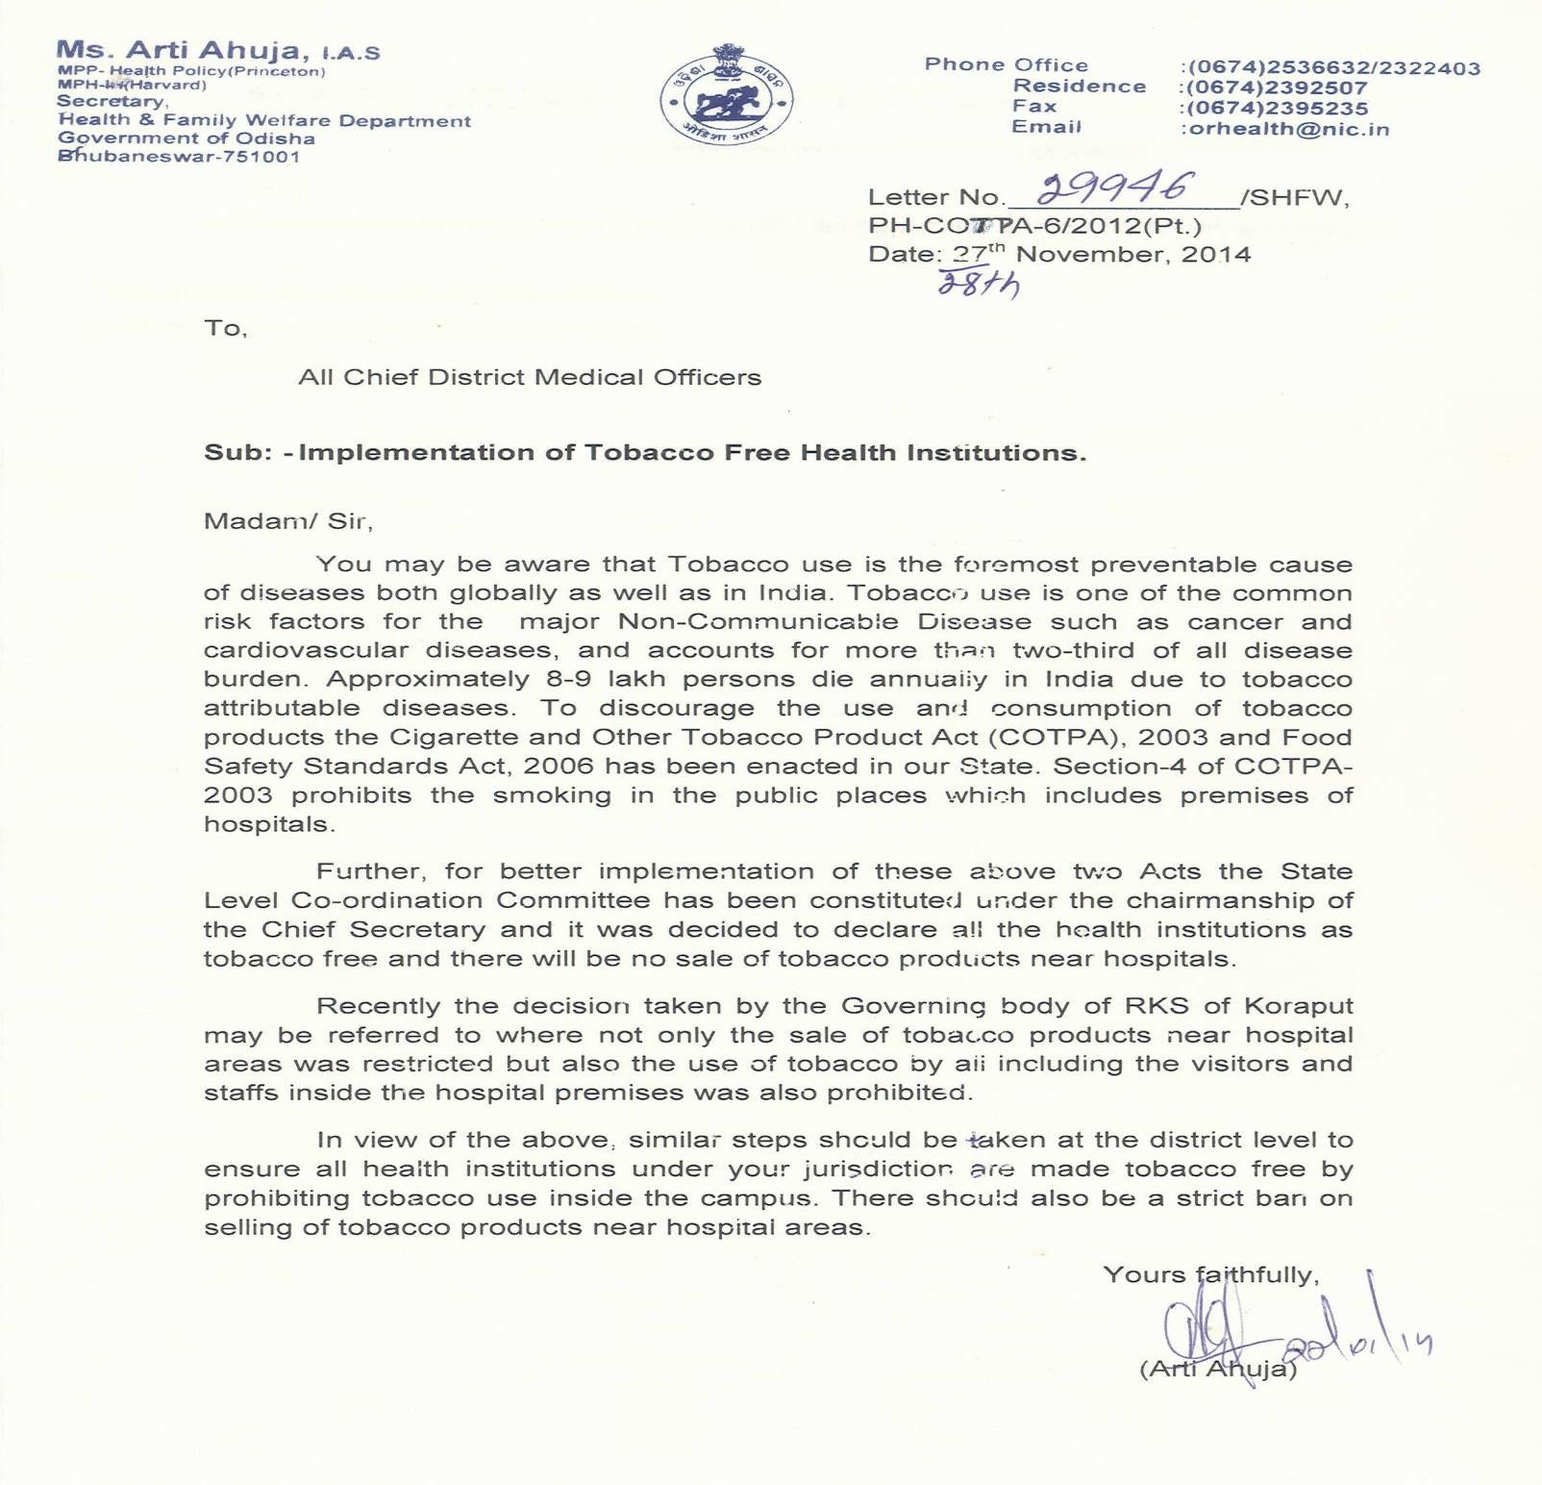

QUALITY POLICY

National Quality Framework for Public Health Facilities
Quality of Care has emerged as key thrust area for both Policy Makers and Public Health Practitioners as an instrument of optimal utilization of resources and improving health outcomes and client satisfaction. The National Health Policy 2016 clearly states in its objective – Improve health status through concentrated policy action in all sectors and expand preventive, promotive, curative, palliative and rehabilitative services provided through the public health sector with focus on Quality.

Ministry of Health & Family Welfare, Government of India in collaboration with state health departments has developed and implementing a comprehensive quality assurance framework for public health facilities and Programs. This Framework comprises of four interrelated approach and activities to achieve patient centric quality system

- Instituting Organizational Framework for Quality
- Defining Standards of Service Delivery and Patient Care
- Continuous Assessment of services against set standards
- Improving Quality through closing gaps and implementing opportunities for Improvement.

The framework based works on following principles –

- Systems approach –Quality System should be integral part of Health Systems. Rather than working on isolated themes and facilities, the approach should be holistic quality improvement involving all components of health system. Quality processes should be interlaced with healthcare planning and provision processes to give optimal results. This is achieved by instituting a system of continuous assessment, handholding and participative quality improvement through coordinated efforts of all stakeholders.

- Client Focus –The quality system should enable providers to meet and surpass the expectations of it clients. These may be patients, beneficiaries and community at large. The patient care and quality assurance processes should be designed keeping in mind the users of public health facilities, so these are accessible, affordable, dignified and user- friendly to its seekers. This achieved though taking continuos objective feedback from users and using it for improving the services.
- Recognizing the champions- Healthcare Quality improvement on large scale thrives upon success stories, role models, inspirational leaders and champions to spread quality

culture. The quality framework gives provision of promoting and recognizing champions through incentives and reward mechanism.
- Team work– Quality can only be achieved by concentrated, coordinated and sustainable efforts of all stakeholders be it policy makers, health administrators, clinicians, patient care staff or frontline community health workers. Quality Assurance committees and units have been instituted at National, state and district level to facilitate team work. At facility level Quality Team have been constituted so all service providers can pool their efforts to for quality improvement.

- Process Focus– Healthcare quality is comprises for three components – structure, process and outcome. The desired outcome can only be achieved when optimal infrastructure and human resources is utilized by efficient processes. Though structure is important component to ensure quality, National Quality Framework is predominately relying on improving the outcome by optimizing the processes within given structural limitations. This is achieved by through assessment, improvement and standardization healthcare processes.

- Continual Improvement –Quality is a long journey, requires concentrated and sustained efforts. The quality framework believes in incremental improvement in healthcare process through continual quality improvement cycle. This enables serviceproviders.
- Objective Quality Measurement – The journey towards quality improvement starts with objective and unbiased measurement of quality of existing healthcare processes and services. Under Quality Framework, National Quality Assurance Standards have been instituted of all level of public health facilities. Explicit assessment tools and scoring system has been developed for objective measurement and fact based decision making for quality improvement.
- Concern & Context – Public Hospitals service a large section of community those don’t have access to private health care because of affordability or access. Public system also has almost exclusive responsibility for implementing preventive and promotive health programs. National Quality Framework works towards develop indigenous quality system of public health facilities that meets specific requirements of its users as well global benchmarks.

AVAILIBILITY OF EDL AND STOCKOUT MANAGEMENT POLICY
Government of Odisha has the mandate to improve access to quality healthcare including medicine and diagnostics for the entire population of the state . The declaration of “Free Medicine Distribution Scheme”by the government is one such step taken in that direction. The Aim of the scheme is to ensure availability of essential medicines ,within the context of functioning health facilities ,at all times ,in adequate quantity,in the

appropriate dosage with assured quality ,available adequate information and at free of cost.
Department of Health and Family Welfare, Government of Odisha, has taken various measures to ensure successful implementation of the Scheme. The need for an appropriate reform strategy based on empirical evidence was felt necessary to bring about order in the system and to ensure sustainable improvement in accessibility of medicines at government health facilities. The need for an indepth assessment of the issues and challenges relating to accessibility to essential drugs was of paramount importance; more so when almost 68% of the people in India have limited or no access to essential medicines
- In view of above facts, Indian Institute of Public Health(IIPH) at Bhubaneswar, was Commissioned through the Technical Management and Support Team (TMST) under DFID Supported Odisha Health Sector and Nutrition Plan (OHSNP) to carry out a rapid assessment of availability of drugs at government health facilities. It has the following objectives:
  - Assess the extent of availability and stock out of essential medicines and other medical supplies at the health facilities;
  - Analyse consumption patterns at different levels of health facilities to facilitate rational drug budgeting and better procurement planning ; and
  - Identify the factors that drive both availability and consumption of essential drugs at health facilities.
IIPH started field assessment process during Sept’14 with concurrence of the department. The assessment tools, methodology and the approach were finalised in consultation with the government counterparts. The first draft report was submitted by IIPH in the 1stweek of Dec’14. The meeting on sharing the assessment findings with department officials was held on 22ndDec’14. The findings and recommendations were deliberated upon in detail and an action plan agreed. It was also agreed that the new procurement and inventory management system, which is under implementation
- WHO report on the world’s medicines situation through Odisha State Medical Corporation Limited
- shall address the majority of the issues identified. The report on the rapid assessment clearly depicts the survey findings and provides appropriate analysis. The survey findings are detailed out within the report and have been summarized under separate heads. In line with the study findings the report also recommends both short term and long term measures for improving drug availability at the facilities.
The minutes of the meeting held with the department on sharing first hand findings of
the rapid assessment study,along with the recommended action plan as agreed,is enclosed herewith for reference and the records of the department.

AVAILIBILITY OF EDL AND STOCK OUT MANAGEMENT POLICY
Policy of Avoiding stock outs of drugs and consumables and ensuring drugs as per EDL
Policy Name : | Policy of Avoiding stock outs of drugs and consumables and ensuring drugs as per EDL
Date of implementation :
Approved By : | Superintendent in Medical Superintendent
 | Name : Dr ……………….
 | Signature :
Reviewed By: | CHC Quality Assurance Team (Incharge / Member)
 | Name : Dr …………………..
  - Purpose: To provide guideline instructions for effective management of pharmacy in which drugs & consumables were not get stock out as per EDL.

  - Scope: It covers all activities under the pharmacy services
  - Responsibility Person:
Medical Officer In charge of Pharmacy, Chief Pharmacist, Pharmacist and

Nursing Staff
  - Policy:
    - Some common systems for arranging medicines include:-
- Alphabetical order by generic name: When using this system, the labeling must be changed when the Essential Medicines List is revised or updated.
- Therapeutic or pharmacologic category: Most useful in small storerooms or dispensaries where the storekeeper is very knowledgeable about pharmacology.
- Dosage form: Medicines come in different forms, such as tablets, syrups, injectables, and external use products such as ointments and creams. In this system, medicines are categorized according to their dosage form. Within the area for each form, a fixed, fluid, or semi-fluid system is used to store items. Any of the other methods of categorizing can be used to organize the items more precisely.
- System level: Items for different levels of the health care system are kept together. This works well in stores at a higher level when storage of kits is required.
- Frequency of use: Frequently used products that move quickly or often through the store should be placed in the front of the room or closest to the staging area. This system should be used in combination with another system.
- Random bin: Identifies a specific storage space or cell with a code that corresponds to its aisle, shelf, and position on the shelf. This system requires computer automation. g) Commodity coding: Each item has its own article and location code. This system has the greatest flexibility, but it is also the most abstract. Stores staff do not need any technical knowledge of the products to manage this system because the codes contain the information needed for storing products properly, such as temperature requirements, level of security, and flammability. This system works well in computerized inventory control systems.
- Separate storage of items of resale potential (high value items, narcotics, psychotropic drugs) and flammable liquids (acetone, alcohol, anesthetic ether and store in security zones.
- Stock rotation

- Follow First to Expire First to be Out (FEFO) procedure.
- Place products that will expire first in front.
- Write expiry date on product card.
- For items which do not have an expiry date, the principal to be followed is FIFO-First in First Out.
- Put newly received items at the back of existing stock
- Always remove expired and poor quality stock from the store
- Identify overstocked items and items that are not in use and distribute them to other facilities
- Keep a record of all items removed so that balances can be tallied later.
    - Regular counting of drugs in register and issue the drugs according to FEFO (First Expire First Out) Procedure
    - Drugs should be present in excess which drug are used in large amount or prescribed more in numbers by Doctors
    - A well-managed distribution system should:
      - Maintain a constant supply of drugs
      - Keep drugs in good condition
      - Minimize drug losses due to spoilage and expiry
      - Rationalize drug storage points
      - Use available transport as efficiency as possible
      - Reduce theft and fraud
      - Provide information for forecasting drug needs The distribution cycle begins when drugs are dispatched by the manufacturer or supplier. It ends when drug consumption information is reported back to the procurement unit
Advantages:
- The drugs when purchased in bulk may be bought for a lower price directly from the manufacturers
- Transportation of these drugs is borne by the supplying firm
- Loss/ theft during transport is the responsibility of the firm.
    - The entire drug management can be assessed based on four major indicators :
1. Total expenditure on drugs and medicines (percentage of total expenditure on health) 2. Total expenditure on drugs and medicines (per capita average)
3. Government expenditure on drugs (per capita average)

4. Private expenditure on drugs (per capita average)
    - The drug supply management at a health facility has seven components for avoiding stock outs of drugs and consumables as per EDL:
- Preparation of drug store
- Supply ordering
- Receiving supplies
- Organization of drug supplies
- Inventory Management
- Record keeping
    - Medical stores must have a system for classifying or organizing medicines, and must ensure that all employees know the system being used.

